|  |  |  |  |  |  |
| --- | --- | --- | --- | --- | --- |
| Date | 1-Dec-22 | | | Tester Name | Mayuri Patel |
| Environment | Penfax - Test | | | Login used |  |
| Operating System | Select OS | Version: | Update: | | |
| Software Used | Select Software | Version: | Update: | | |
| Select Software | Version: | Update: | | |
| Release version | 22.4.1 | | | | |
| Title |  | | | | |
| Test Type | Regression | | | | |
| Test Scenario | Set up VPB for past member | | | | |
|  |  | | | | |
| Expected Results |  | | | | |
| Pass/Fail | Pass | | | JIRA# | N/A |

Describe your steps with screenshots:

Search for a deferred PEPP active member and age > 55

Open that member Profile

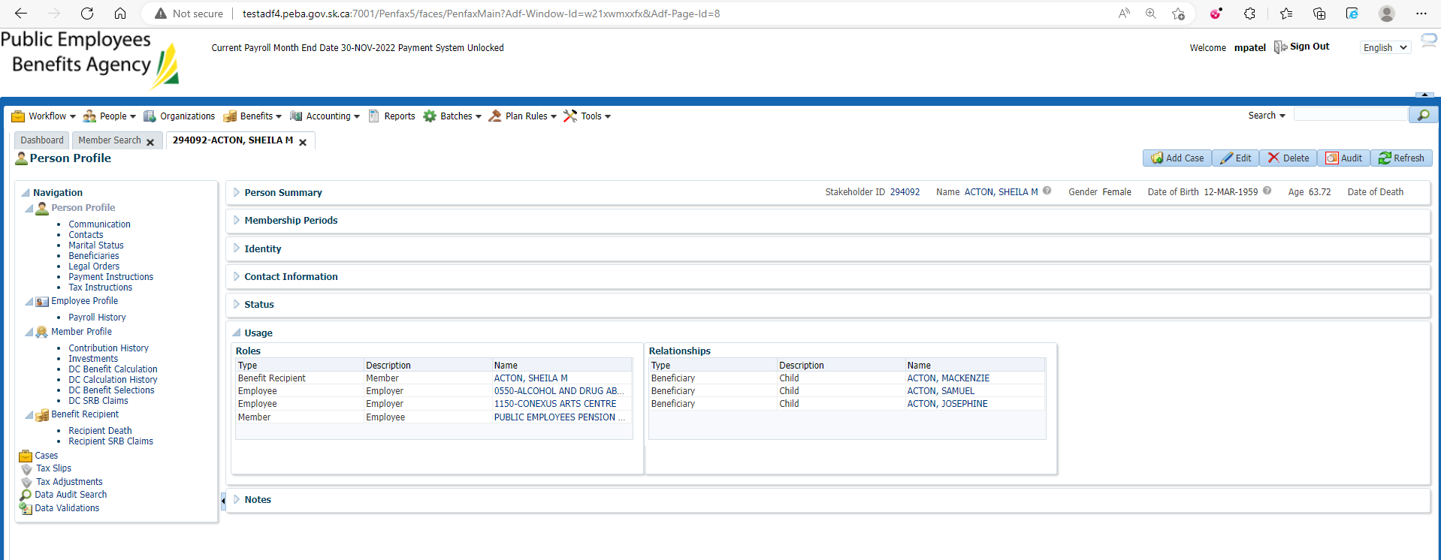

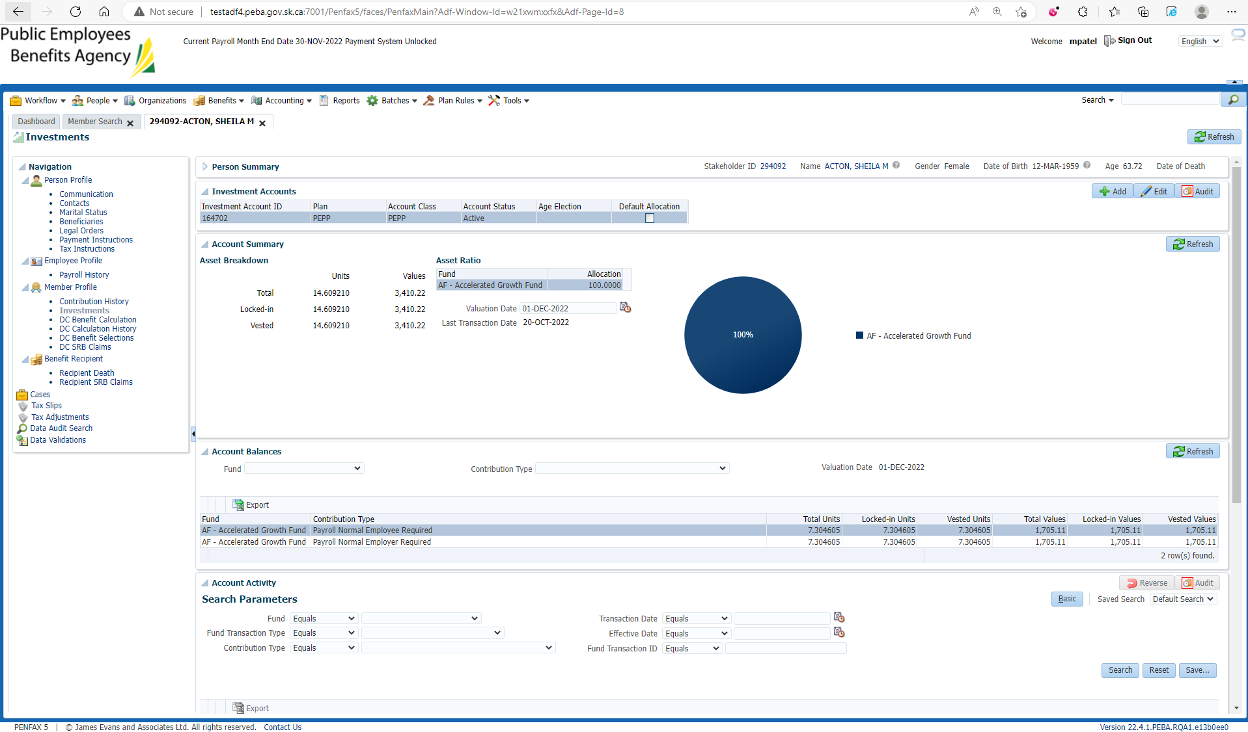

Go to DC Benefit Selection

Enter retirement date and Next

Allocate all funds to VPB Account

Submit for Approval and approve it

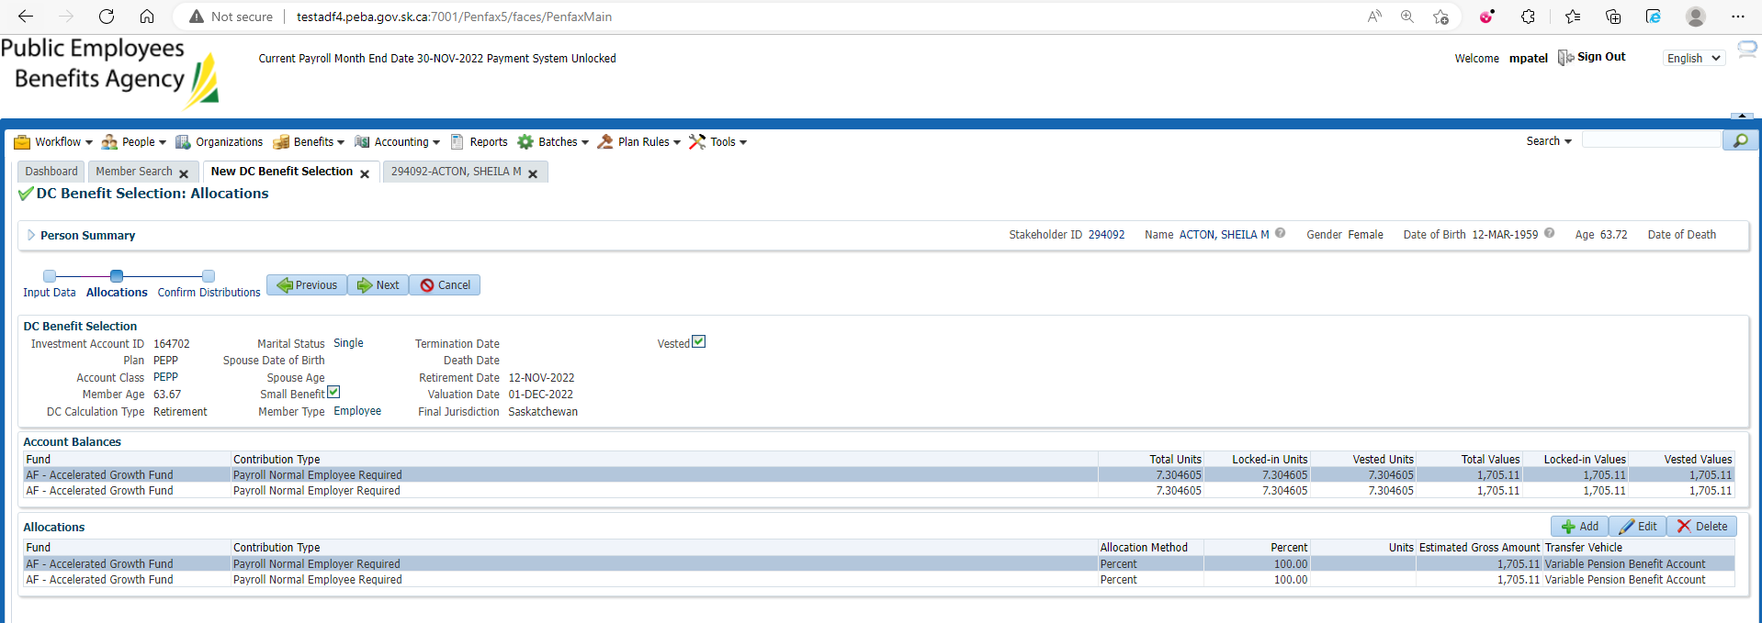

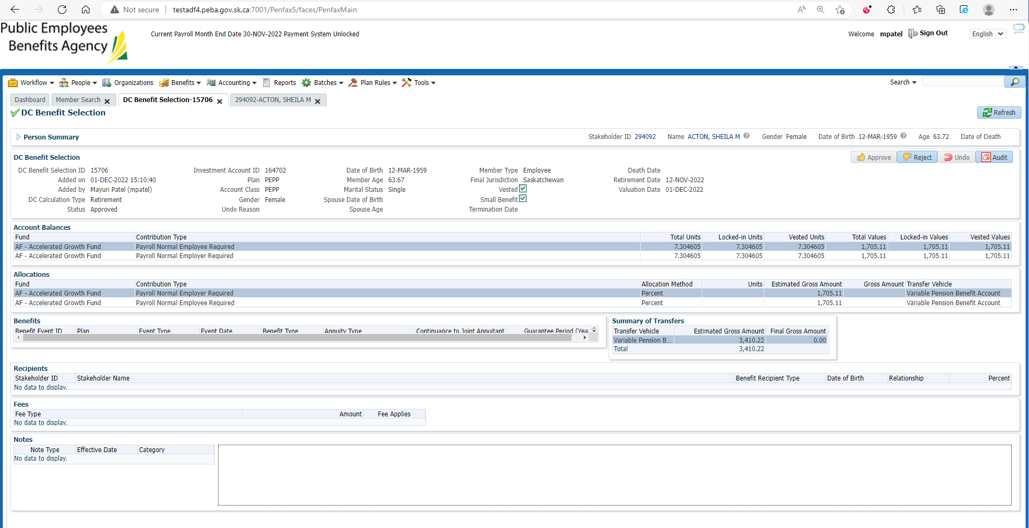

After Overnight PIT Batch

Open that member profile again

Go to Investments under member profile

Make sure PEPP account is Inactive and VPB account is active now

